How to: Setup a BCC rule in O365

02/10/19

This document aims to guide the setup and testing of an O365 BCC mail flow rule. The BCC rule is used to send traffic to a Glasswall PoC tenant.

# Create a Contact in Exchange Admin Center

1. Within Exchange admin center: [Click] recipients.
2. [Click] contacts.
3. [Click] the + button & [Select] Mail contact.

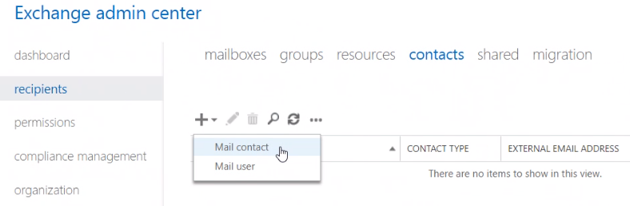

1. Fill in the required fields using the External email address supplied by your Glasswall representative.
2. [Click] Save.

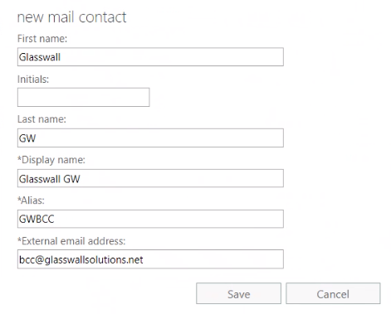

# Create a mail flow BCC rule

1. Within Exchange admin center: [Click] mail flow.
2. [Click] rule.
3. [Click] the + button & [Select] Create a new rule...

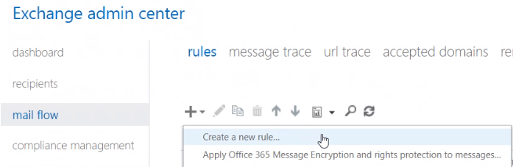

1. Fill in the form as below:
   1. The recipient condition can also be an individual email address or a group of users.
   2. The sender condition is set as to only BCC external inbound traffic.
   3. The attachment size condition is set as to only BCC emails with attachments.
   4. The BCC address is the contact created above.
   5. Your tenant ID can be found in your Glasswall portal:

<https://docs.glasswallsolutions.com/cloud/Content/Configuring/System%20Settings.htm#TenantID>

1. [Click] Save.

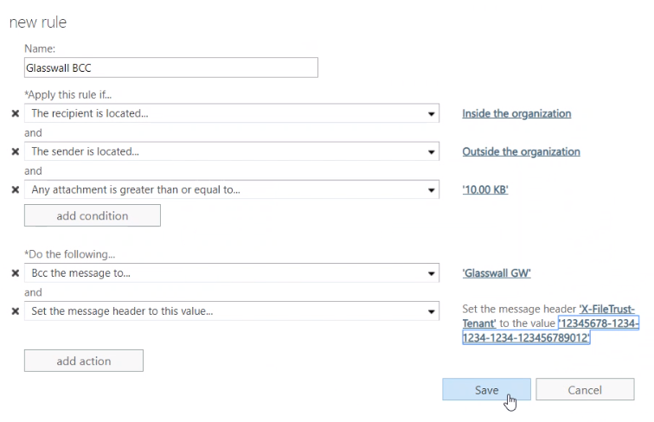

1. [Edit] the transport rule using the pen icon.
2. Set the Priority to 0 so that is the first rule to be processed.

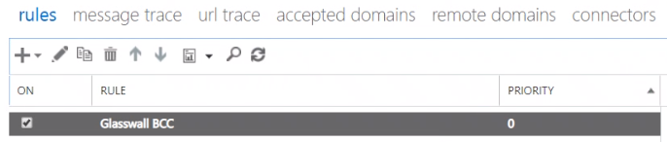

# Message Trace – Testing

A message trace can be used to search for test mails to confirm that the BCC rules set above have been correctly applied. O365 can take up to 30 mins to apply a new rule.

1. Within O365 Security & Compliance: [Click] Mail flow.
2. [Click] Message trace.
3. [Click] + Start a trace.

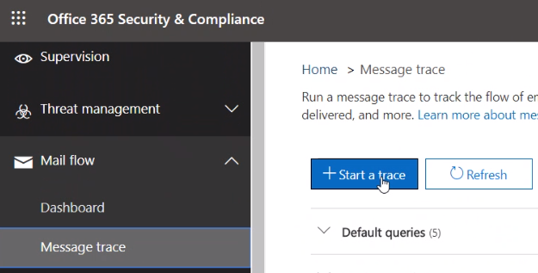

1. Set an appropriate receiver address.
2. Set the required time period for the search.

